LAB REPORT - EXPERIMENT 1

COEN 316 – Computer Architecture – Fall 2024
Section WC - X

Lab performed on : January 29th 2025
Report submitted on : February 12th 2025

Lab performed and report written by : Simon Guindon – 40058301

TA Instructor:
Umair Hussain

Introduction and Objective
This experiment’s objective is to introduce the experimenter to designing an arithmetic and logic unit (known as ALU). To do so, we performed two versions of an ALU code, one with a 32 bits input and one with a 4 bits input, so that the code would be physically testable on a Nexys A7 board.
Theory and Results
The usefulness of an ALU in a hardware system is that it can take two 32 bits inputs and generate a 32 bits output depending on the needs of the system. As such, it serves as a computational component that lets a processor complete various important tasks. For example, accessing a memory address from a base memory address plus an increment can be done with the addition operation in the ALU. Many other tasks can also be done like subtraction, multiplication, as well as the logical operations AND/OR/XOR/NOT. In this lab, we implemented an ALU on a board as illustrated in Figure 1 below:
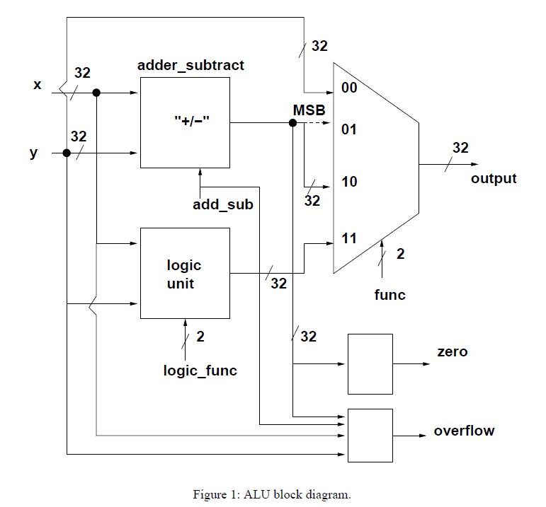
The ALU consists of three sub units, the first one being an addition or substraction unit, where the two inputs x and y will either be added or subtracted depending on the value of add_sub. The second one is a logic unit where the AND, OR, XOR, NOR operation takes place depending on the value of logic_func. Finally, a mux will take as input either the 32 bits result of the logic unit, the 32 bits result of the add/sub unit, the most significant bit from the add/sub unit, or the value of y, depending on the value of func. In addition, the ALU tracks whether or not the value for the add/sub unit resulted in 0, and an overflow detector is also present by taking as input the value for x and y, the add_sub value and the result of the add/sub unit.
Results
Section 1.1 – Testing ModelSim’s output for ALU.vhd
The first thing that I will test is that the mux select behaves as expected. We expect the output to be y when func is 00, the MSB of x and y’s addition when func is 01, the result of adding x and y when func is 10 and the result of performing AND on x and y when func is 11.
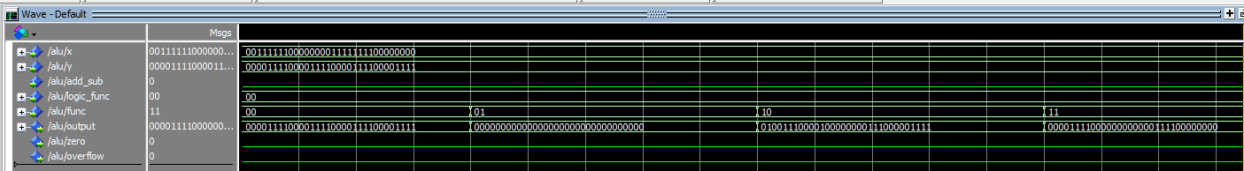
As expected, the output is y when func is 00 (0000 1111 0000 1111 0000 1111 0000 1111),
the output is the MSB of x and y when func is 01 (0000 0000 0000 0000 0000 0000 0000 0000),
the output is the sum of x and y when func is 10 (0100 1110 0001 0000 0000 1110 0000 1111),
the output is the result of AND on x and y when func is 11 (0000 1111 0000 0000 0000 1111 0000 0000),
The next thing that I will test is that the addition and substraction operation behaves as expected. Since addition was proven functional in the previous step, we will perform a subtraction.
By forcing x to a value of 0011 1111 0000 0000 1111 1111 0000 0000
and forcing y to a value of 0000 1111 0000 1111 0000 1111 0000 1111, the subtraction
should yield a result of 0010 1111 1111 0001 1110 1111 1111 0001 when add_sub is set to 1, and func is 10 (meaning the whole value of adder_subtract goes to output). As shown below, we get the expected result.
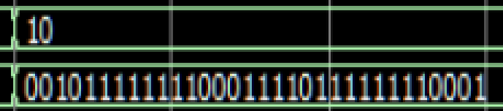
The next thing that I will test is that the logic operation behaves as expected. Since AND was proven functional in the previous step, we will perform OR XOR NOR operations.
By forcing x to a value of 0011 1111 0000 0000 1111 1111 0000 0000
and forcing y to a value of 0000 1111 0000 1111 0000 1111 0000 1111,
the OR yield a result of 0011 1111 0000 1111 1111 1111 0000 1111 when add_sub is set to 1, and func is 10 (meaning the whole value of adder_subtract goes to output). As shown below, we get the expected result.
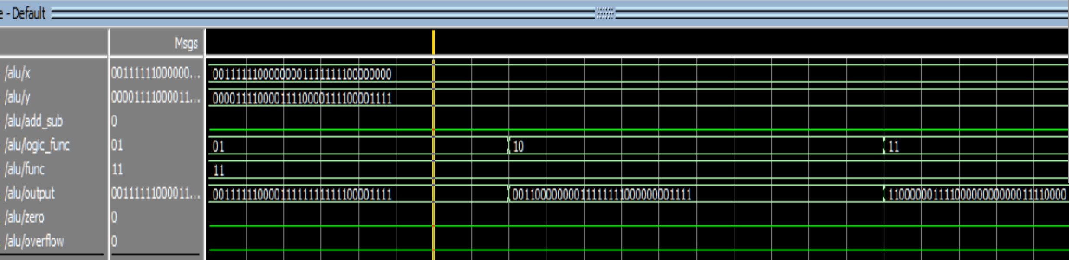
The result for the XOR gate is 0011 0000 0000 1111 1111 0000 0000 1111 as expected and the result for the NOR gate is 1100 0000 1111 0000 0000 0000 1111 0000 as expected.
The last thing to test is the zero and overflow behavior. For this section, we will have x and y be all zeros and add them, then have x and y be all ones and add them.
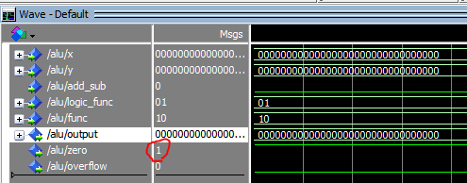
Zero takes the value 1 as expected when x and y are all zeros.
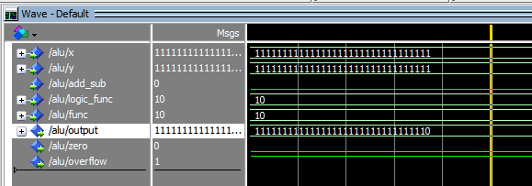
Overflow takes the value 1 as expected when x and y are all ones.
Section 1.2 – Testing ModelSim’s output for ALU_wrapper.vhd
For the sake of completeness, the ModelSim results for the wrapper will be illustrated below, but to avoid repetitiveness, I will only include the pictures of the ModelSim output in the same order that appears above. The results reflect the expected values as explained above:
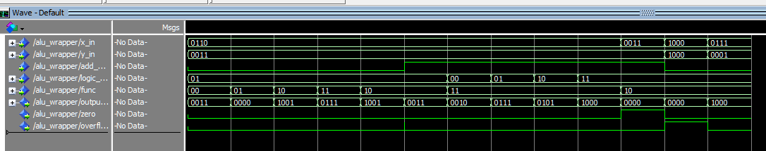
Mux select behavior:
The output is correctly y (0011) when func is 00.
The output is correctly the MSB (0000) when func is 01.
The output is correctly the sum of x (0110) and y (0011) resulting in 1001 when func is 10.
The output is correctly the OR of x and y (0111) when func is 11.
Add/Sub behavior
The output is correctly the sum of x (0110) and y (0011) resulting in 1001 when func is 10.
The output is the difference of x (0110) and y (0011) resulting in 0011 when func is 10 and add_sub is 1.
Logic Operation behavior
The output is correctly the AND of x and y (0010) when logic is 00.
The output is correctly the OR of x and y (0111) when logic is 01.
The output is correctly the XOR of x and y (0101) when logic is 10.
The output is correctly the NOR of x and y (1000) when logic is 11.
Zero and Overflow behavior
The zero is correctly 1 when x and y are the same value (0011) and subtracted.
The overflow correctly detects when x (1000) and y (1000) are added but would give a value over 1111.

Section 2.1 – VHDL source code for ALU.vhd
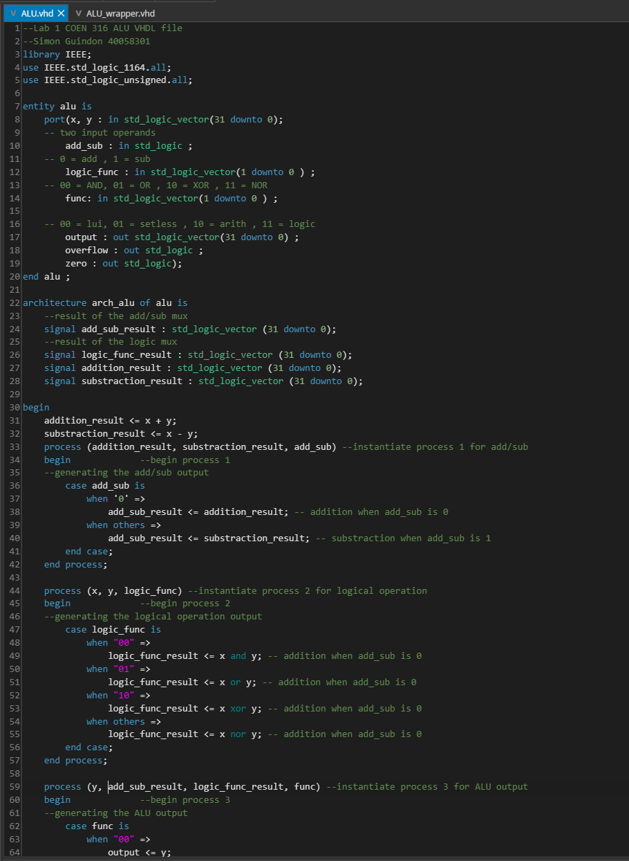
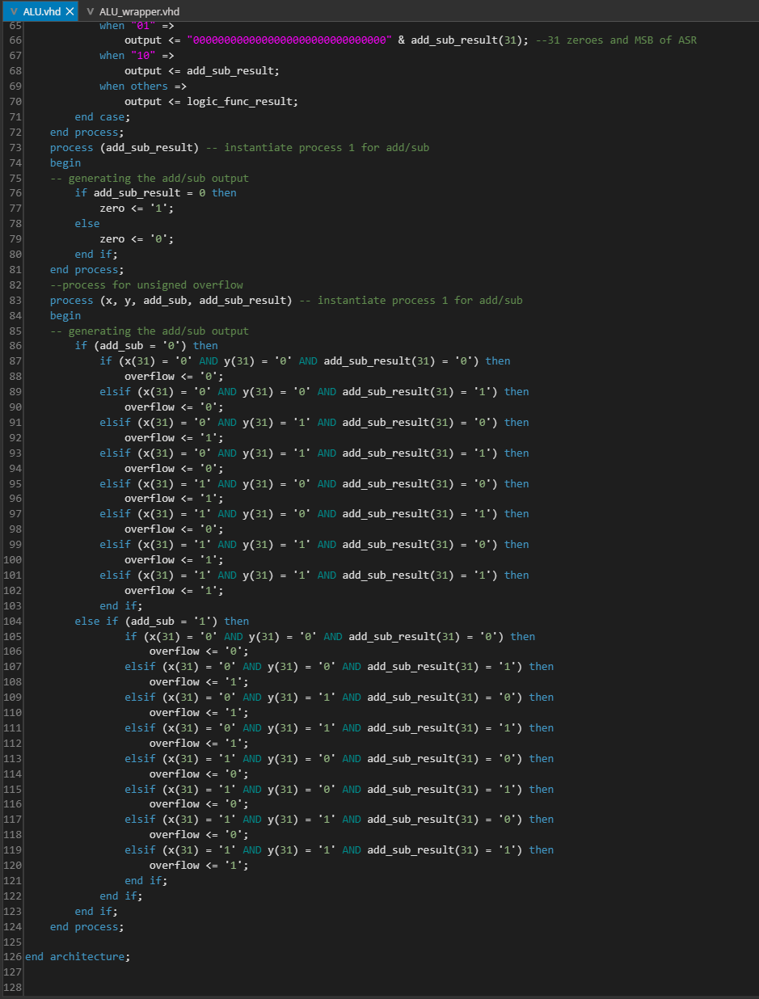
Section 2.2 Source code for ALU_wrapper.vhd
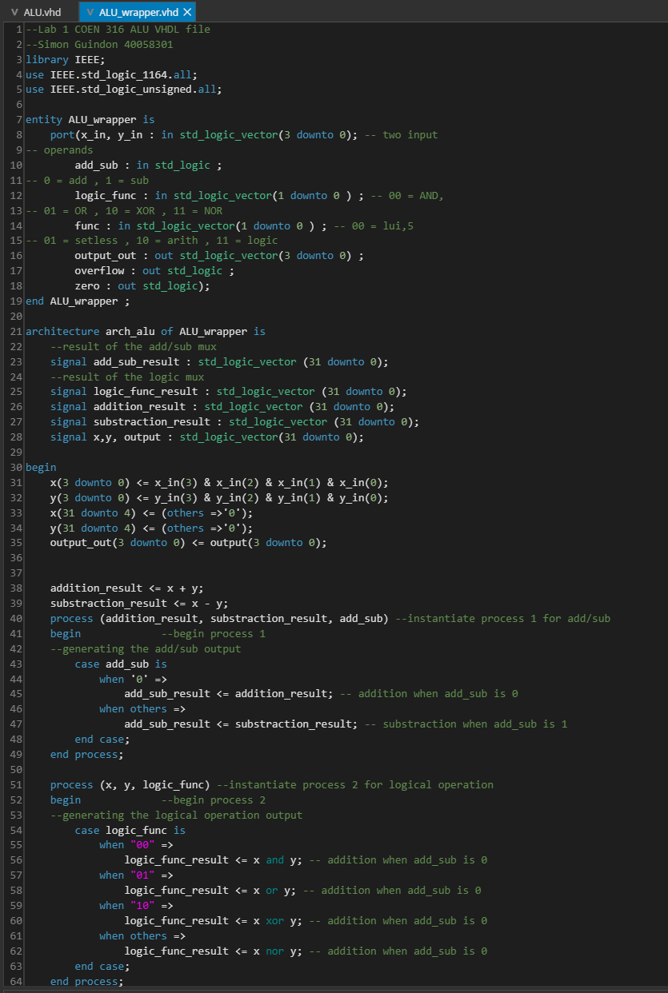 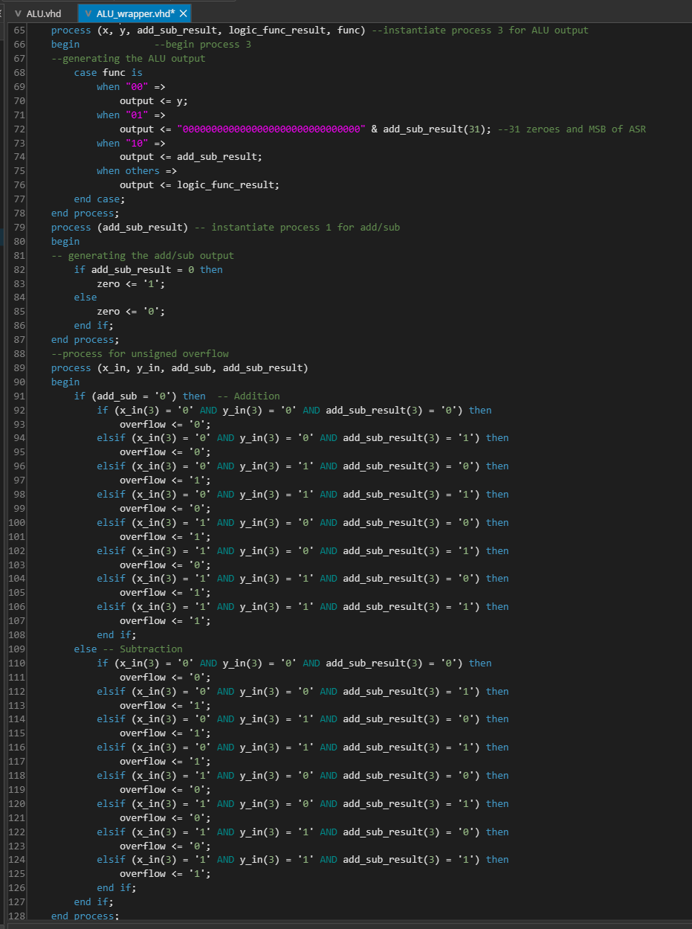
Conclusion
In conclusion we had our first experience building two versions of an ALU, one with a full 32 bits input and a wrapper that can be presented on a Nexys A7 board. The results we obtained were in agreement with the theoretical output for the ALU. Future labs will incorporate this ALU design into more complex systems.

;

